
Operating

System

Lab

(
N
-
PCCCM401P)

S.B. JAIN INSTITUTE OF TECHNOLOGY
MANAGEMENT

&

RESEARCH,

NAGPUR

Practical

11

Postlab

(
OPEN

ENDED

PRACTICAL)

Aim:
To implement and compare different page replacement algorithms (FIFO
and LRU) and analyze their performance based on page faults.

N
ame:

Yashwant Sirsate

USN:CM240
6
0

Semester / Year:4
^{th}
/2
^{nd}

Academic Session:2025
-
26

Date of Performance:

Date of Submission:

Operating System Lab (N-PCCCM401P)

- Aim: To implement and compare different page replacement algorithms (FIFO and LRU) and analyze their performance based on page faults.
- Objectives:
  - To understand memory management in Operating System
  - To study page replacement algorithms
  - To calculate number of page faults
To compare FIFO and LRU performances

Requirements
✔ Hardware Requirements:
- Processor: Minimum 1 GHz
- RAM: 512 MB or higher • Storage: 100 MB free space
✔ Software Requirements:
- Operating System: Linux/Unix-based
- Compiler: GCC
- Text Editor: Nano / Vim / VS Code

Theory:
Page replacement is a memory management technique used in Operating Systems. When a process requires a page that is not in memory, a page fault occurs. If memory is full, the OS replaces an existing page with a new one. FIFO (First In First Out)
- Oldest page is replaced first
- Simple to implement
- May lead to more page faults
LRU (Least Recently Used)
- Replaces the page that has not been used for the longest time
- More efficient than FIFO
- Requires tracking of page usage
Page replacement algorithms are important for improving memory utilization and system performance.

Department of Emerging Technologies, SBJITMR, Nagpur.

Operating System Lab (N-PCCCM401P)

❖ CODE:
#include <stdio.h>

void fifo(int pages[], int n, int capacity) { int frame[10], i, j, k = 0, page_faults = 0;

for (i = 0; i < capacity; i++) frame[i] = -1;

for (i = 0; i < n; i++) { int found = 0;

for (j = 0; j < capacity; j++) { if (frame[j] == pages[i]) {
found = 1; break;
}
}

if (!found) { frame[k] = pages[i]; k = (k + 1) % capacity; page_faults++;
}
}

printf("FIFO Page Faults = %d\n", page_faults); }

void lru(int pages[], int n, int capacity) { int frame[10], time[10], i, j, pos, page_faults = 0, counter = 0;

for (i = 0; i < capacity; i++) frame[i] = -1;

for (i = 0; i < n; i++) { int found = 0;

for (j = 0; j < capacity; j++) { if (frame[j] == pages[i]) {
counter++; time[j] = counter; found = 1; break;

Operating System Lab (N-PCCCM401P)

}
}

if (!found) { if (i < capacity) { frame[i] = pages[i]; time[i] = ++counter;
} else {
int min = time[0];
pos = 0;

for (j = 1; j < capacity; j++) { if (time[j] < min) { min = time[j];
pos = j;
}
}

frame[pos] = pages[i];
time[pos] = ++counter;
}
page_faults++;
}
}

printf("LRU Page Faults = %d\n", page_faults); }

int main() { int pages[] = {1, 2, 3, 4, 1, 2, 5, 1, 2, 3, 4, 5}; int n = 12; int capacity = 3;

fifo(pages, n, capacity);
lru(pages, n, capacity);

return 0;
}
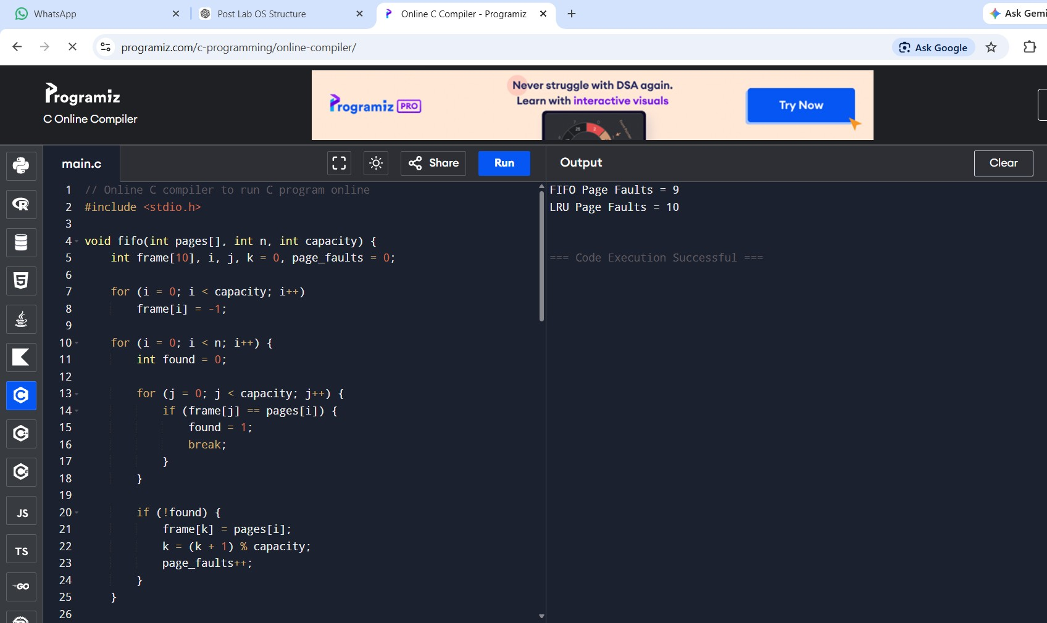
Operating

System

Lab

(
N
-
PCCCM401P)

❖

Output:

❖

Conclusion
:

Page replacement algorithms are essential for efficient
memory management. FIFO is simple but less efficient, whereas LRU
provides better performance by reducing page faults.

❖

Discussion

Questions:

1.

What is a page fault?

2.

What is page replacement?

3.

Difference between FIFO and LRU?

4.

Which algorithm is more efficient and why?

5.

What is Belady’s anomaly?

Operating System Lab (N-PCCCM401P)

❖ References:
• https://www.geeksforgeeks.org/page-replacement-algorithms-in-operating-systems/

Date: / /2026

Signature
Course Coordinator
B.Tech CSE(AIML)
Sem: 4 / 2025-26

Department of Emerging Technologies, SBJITMR, Nagpur.

